**DATA SCIENCE**

**LAB CYCLE -1**

**1. Program to Print all non-Prime Numbers in an Interval**

**n1=int(input("enter a number"))**

**n2=int(input("enter a number"))**

**for i in range(n1 , n2):**

**for j in range(2 , i):**

**if(i % j) == 0:**

**print(i)**

**break**

**OUTPUT**

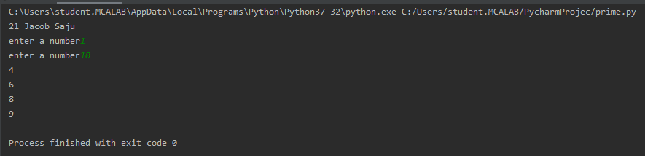

**2. Program to print the first N Fibonacci numbers.**

**nterms = int(input("How many terms? "))**

**n1, n2 = 0, 1**

**count = 0**

**if nterms <= 0:**

**print("Please enter a positive integer")**

**elif nterms == 1:**

**print("Fibonacci sequence upto",nterms,":")**

**print(n1)**

**else:**

**print("Fibonacci sequence:")**

**while count < nterms:**

**print(n1)**

**nth = n1 + n2**

**n1 = n2**

**n2 = nth**

**count += 1**

**OUTPUT**

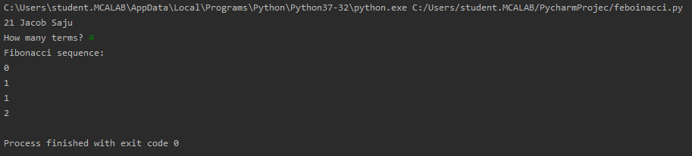

**3. Given sides of a triangle, write a program to check whether given triangle is an isosceles, equilateral or scalene.**

**n1 = int(input("enter the side1:"))**

**n2 = int(input("enter the side2:"))**

**n3 = int(input("enter the side3:"))**

**if n1 == n2 and n1 == n3:**

**print("triangle is equilatrel")**

**elif n1 == n2 or n1 == n3 or n2 == n3:**

**print("triangle is isoceless")**

**else:**

**print("triangle ids scalar")**

**OUTPUT**

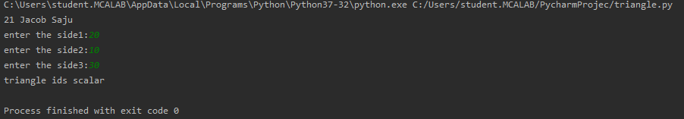

**4. Program to check whether given pair of number is coprime**

def are_coprime(a, b):

hcf = 1

for i in range(1, a + 1):

if a % i == 0 and b % i == 0:

hcf = i

return hcf == 1

first = int(input('Enter first number: '))

second = int(input('Enter second number: '))

if are_coprime(first, second):

print('%d and %d are CO-PRIME' % (first, second))

else:

print('%d and %d are NOT CO-PRIME' % (first, second))

**OUTPUT**

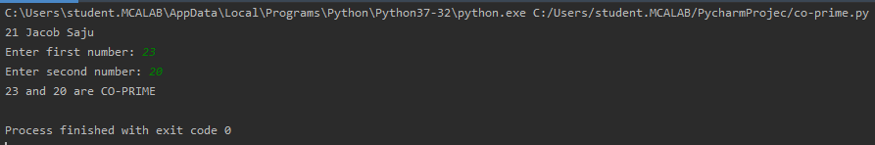

**5. Program to find the roots of a quadratic equation(rounded to 2 decimal places)**

from math import sqrt

print("Quadratic function : (a * x^2) + b*x + c")

a = float(input("a: "))

b = float(input("b: "))

c = float(input("c: "))

r = b**2 - 4*a*c

if r > 0:

num_roots = 2

x1 = (((-b) + sqrt(r))/(2*a))

x2 = (((-b) - sqrt(r))/(2*a))

print("There are 2 roots: %f and %f" % (x1, x2))

elif r == 0:

num_roots = 1

x = (-b) / 2*a

print("There is one root: ", x)

else:

num_roots = 0

print("No roots, discriminant < 0.")

exit()

**OUTPUT**

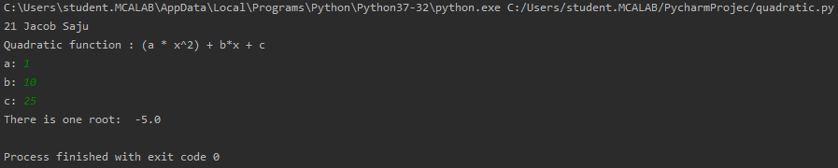

**6. Program to check whether a given number is perfect number or not(sum of factors=number)**

**n=int(input("enter the no:"))**

**sum=0**

**for i in range(1,n):**

**if (n % i == 0):**

**sum=sum+i**

**if (sum == n):**

**print("perfect number")**

**else:**

**print("not perfect number")**

**OUTPUT**

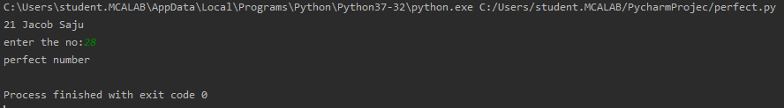

**7. Program to display armstrong numbers upto 1000**

n = int(input("Please enter a number : "))

for n in range(1,n):

if(int(n/100)**3 + int((n%100)/10)**3 + int((n%100)%10)**3 == n):

print(n)

**OUTPUT**

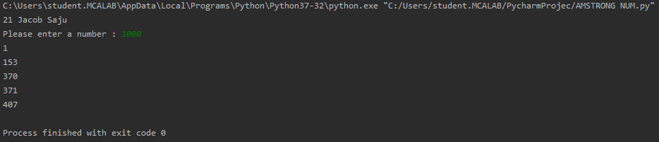

**8. Store and display the days of a week as a List, Tuple, Dictionary, Set. Also demonstrate different ways to store values in each of them. Display its type also.**

list1=['sunday','monday','tuesday','wednesday','thursday','friday','saturday']

tuple1=('sunday','monday','tuesday','wednesday','thursday','friday','saturday')

set1={'sunday','monday','tuesday','wednesday','thursday','friday','saturday'}

dict1={'1':'sunday','2':'monday','3':'tuesday','4':'wednesday','5':'thursday','6':'friday','7':'saturday'}

print(list1,type(list1))

print(tuple1,type(tuple1))

print(set1,type(set1))

print(dict1,type(dict1))

**OUTPUT**

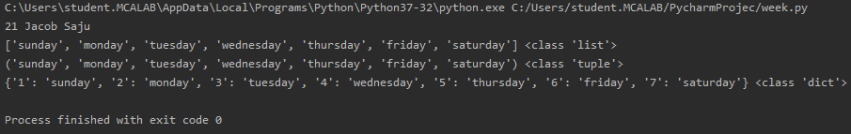

**9. Write a program to add elements of given 2 lists**

n1=int(input("enter the list 1 size:"))

list1=[]

print("enter the values of list 1:")

for i in range(0,n1):

x=int(input())

list1.append(x)

n2=int(input("enter the list 2 size:"))

list2=[]

print("enter the values of list 2")

for i in range(0,n2):

y=int(input())

list2.append(y)

print(list1)

print(list2)

list3=[]

if n1==n2:

for i in range(0,n1):

element=list1[i]+list2[i]

list3.append(element)

print(list3)

else:

print("No of elements are not equal")

**OUTPUT**

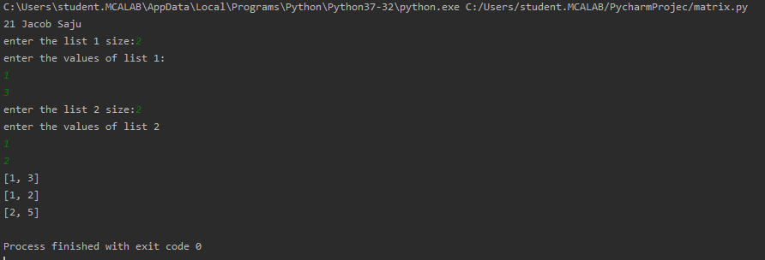

**10. Write a program to find the sum of 2 matrices using nested List.**

n1=int(input("enter the no of rows of 1st matrix:"))

n2=int(input("enter the no of coloumns of 1st matrix:"))

print("Enter the elements")

matrix=[]

for i in range(0,n1):

a=[]

for j in range(0,n2):

a.append(int(input()))

matrix.append(a)

for i in range(0,n1):

for j in range(0,n2):

print(matrix[i][j], end = " ")

print()

n1=int(input("Enter the number of rows for 2nd matix"))

n2=int(input("Enter the number of columns for 2nd matix"))

print("Enter the elements")

matrix2=[]

for i in range(0,n1):

b=[]

for j in range(0,n2):

b.append(int(input()))

matrix2.append(b)

for i in range(0,n1):

for j in range(0,n2):

print(matrix2[i][j], end = " ")

print()

print("Matrix sum is:")

result = [[0, 0, 0], [0, 0, 0], [0, 0, 0]]

for i in range(0, n1):

for j in range(0, n2):

result[i][j] = matrix[i][j] + matrix2[i][j]

for r in result:

print(r)

**OUTPUT**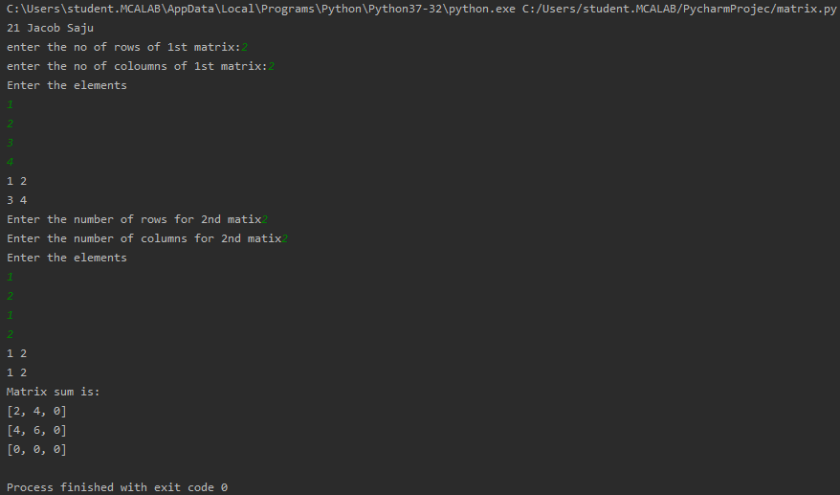

**11. Write a program to perform bubble sort on a given set of elements.**

def bubFunc(a, val):

for i in range(val -1):

for j in range(val - i - 1):

if(a[j] > a[j + 1]):

temp = a[j]

a[j] = a[j + 1]

a[j + 1] = temp

a = []

val = int(input("Please Enter the Total Elements : "))

for i in range(val):

value = int(input("Please enter the %d Element : " %i))

a.append(value)

bubFunc(a, val)

print("The List in Ascending Order : ", a)

**OUTPUT**

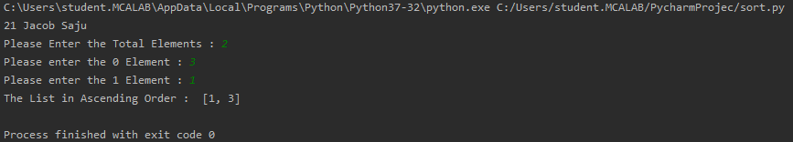

**12. Program to find the count of each vowel in a string(use dictionary)**

str=input("Enter a string:")

print(str)

vowels='aeiou'

print("count of vowels in the string:")

count={}.fromkeys(vowels,0)

for i in str:

for j in count:

if(i==j):

count[j]=count[j]+1

print(count)

**OUTPUT**

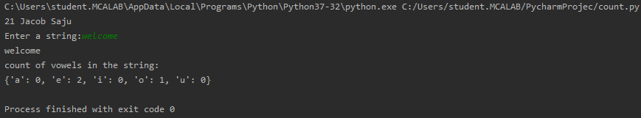

**13. Write a Python program that accepts a positive number and subtract from this number the sum of its digits and so on. Continues this operation until the number is**

**positive(eg: 256-&gt;2+5+6=13**

**256-13=243**

**243-9=232……..**

num=int(input("enter number:"))

def digitsum(num):

sum=0

while num>0:

rem=num%10;

sum=sum+rem;

num=num//10

return sum

while(num>0):

sum=digitsum(num)

print("{} - {} = {}".format(num,sum,num-sum))

num=num-sum

**OUTPUT**

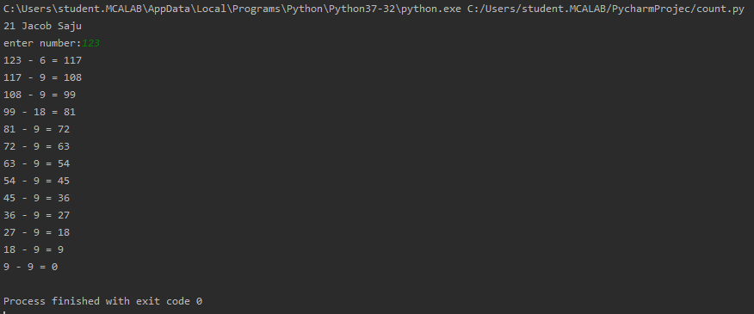

**14. Write a Python program that accepts a 10 digit mobile number, and find the digits which are absent in a given mobile number**

num = int(input("Enter a 10 digit mobile number : "))

nums = []

for i in range(0, 10):

n = num % 10

nums.append(n)

num = num // 10

print("numbers not in the mobile number are : ")

for i in range(0, 10):

if i not in nums:

print(i)

**OUTPUT**

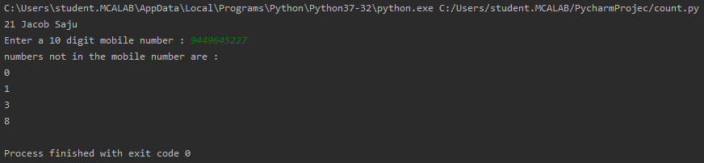

**CYCLE - 2**

1. Create a three dimensional array specifying float data type and print it.

**import numpy as np**

**ar = np.array([**

**[**

**[1,2,3,3,4,5],[2,3,6,7,8,9]**

**],**

**[**

**[1,1,4,6,2,2],[4,1,3,2,5,4]**

**]**

**])**

**print(ar)**

**OUTPUT**

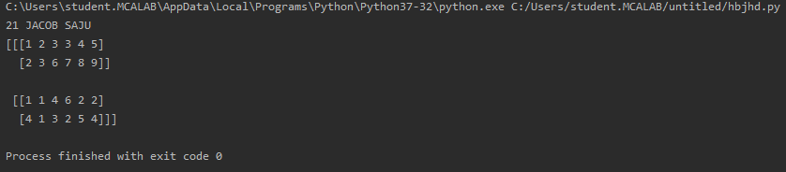

2. Create a 2 dimensional array (2X3) with elements belonging to complex data

type and print it. Also display

a. the no: of rows and columns

b. dimension of an array

c. reshape the same array to 3X2

print("21 Jacob Saju")

import numpy as np

arr = np.array([

[1+4j,2+5j,3+6j],

[4+6j,9+1j,5+2j],

],

dtype=complex)

print(arr)

print("\ndimension of given array is :",arr.ndim)

print("\nnumber of rows and columns of given array is :",arr.shape)

newarr = arr.reshape(3,2)

print("\nnew array is :",newarr)

**OUTPUT**

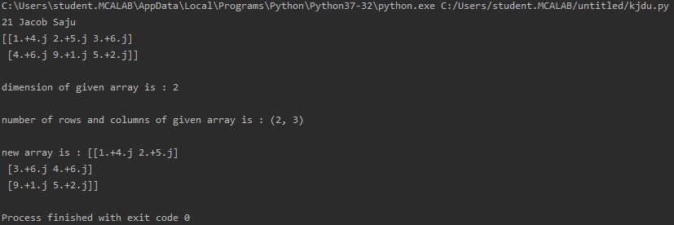

3. Familiarize with the functions to create

a) an uninitialized array

b) array with all elements as 1,

c) all elements as 0

print("21 Jacob Saju")

import numpy as np

arr=np.empty([2,2],dtype="int")

print("an uninitialized array\n",arr)

arr=np.ones([2,2],dtype="int")

print("\narray with all elements as 1\n",arr)

arr=np.zeros([2,2],dtype="int")

print("\narray with all elements as 0\n",arr)

**OUTPUT**

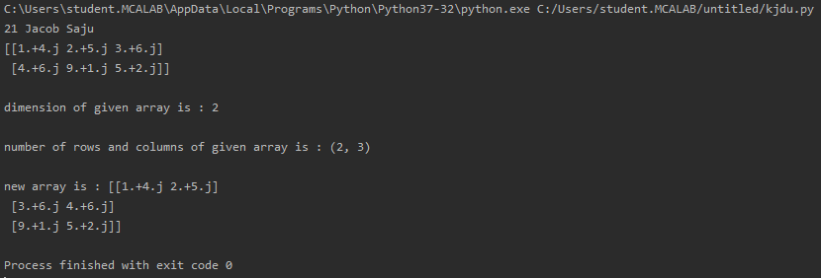

4. Create an one dimensional array using the arrange function containing 10 elements.

Display

a. First 4 elements

b. Last 6 elements

c. Elements from index 2 to 7

print("21 Jacob Saju")

import numpy as np

arr=np.arange(start=1,stop=11,step=1,dtype="int")

print(arr)

print("first 4 elements :\n",arr[:4])

print("last 6 elements :\n",arr[-6:])

print("elements from index 2 to 7 :\n",arr[1:7])

Output:

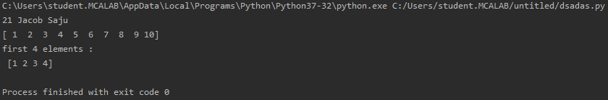

5. Create an 1D array with arange containing first 15 even numbers as elements

a. Elements from index 2 to 8 with step 2(also demonstrate the same

using slice function)

b. Last 3 elements of the array using negative index

c. Alternate elements of the array

d. Display the last 3 alternate elements

print("21 Jacob Saju")

import numpy as np

ar=np.arange(start=0,stop=30,step=2)

print(ar)

print("elements from 2 to 8\n",ar[2:9:2])

print("last 3 elements:",ar[-3:])

print("alternative elements\n",ar[0:30:2])

print("last 3 alternative elements:",ar[:30:2])

Output:

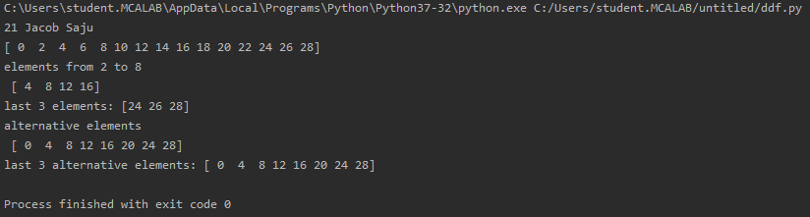

6. Create a 2 Dimensional array with 4 rows and 4 columns.

a. Display all elements excluding the first row

b. Display all elements excluding the last column

c. Display the elements of 1 st and 2 nd column in 2 nd and 3 rd row

d. Display the elements of 2 nd and 3 rd column

e. Display 2 nd and 3 rd element of 1 st row

f. Display the elements from indices 4 to 10 in descending order(use

–values)

print("21 Jacob Saju")

import numpy as np

ar=np.array([[1,2,3,4],

[4,6,7,3],

[8,9,0,1],

[5,6,3,2]

])

print("Display all elements excluding the first row\n",ar[1:4])

print("Display all elements excluding the last column\n",ar[:,0:3])

print("Display the elements of 1 st and 2 nd column in 2 nd and 3 rd row\n",ar[1:3,0:2])

print("Display the elements of 2 nd and 3 rd column\n",ar[:,1:3])

print("Display 2 nd and 3 rd element of 1 st row\n",ar[0,1:3])

Output:

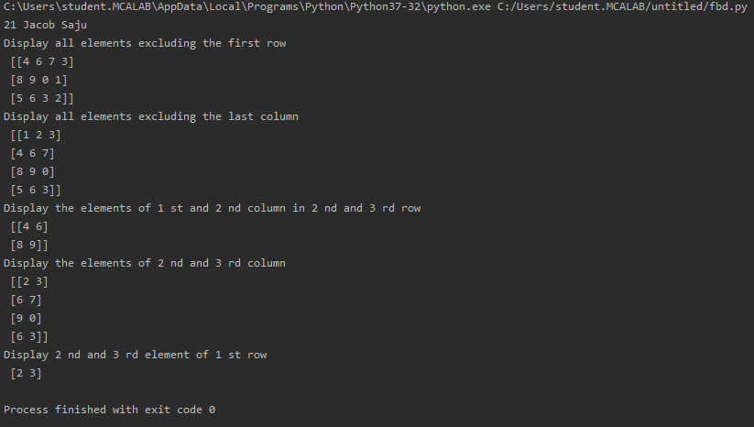

7. Create two 2D arrays using array object and

a. Add the 2 matrices and print it

b. Subtract 2 matrices

c. Multiply the individual elements of matrix

d. Divide the elements of the matrices

e. Perform matrix multiplication

f. Display transpose of the matrix

g. Sum of diagonal elements of a matrix

print("21 Jacob Saju")

import numpy as np

m1=np.array([[1,2,4],

[5,4,3],

[2,3,4]

])

m2=np.array([[2,3,4],

[4,5,4],

[2,3,5]

])

m3=np.add(m1,m2);

print("sum of matrices is:",m3)

m3=np.subtract(m1,m2);

print("Difference between 2 matrices:",m3)

m3=np.multiply(m1,m2);

print("Multiply the individual elements of matrix",m3)

m3=np.divide(m1,m2);

print("Divide the elements of the matrices",m3)

m3=np.matmul(m1,m2);

print("Perform matrix multiplication",m3)

print("Display transpose of the matrix",np.transpose(m1));

print("Display transpose of the matrix",np.transpose(m2));

print("Sum of diagonal elements of a matrix",np.trace(m1));

print("Sum of diagonal elements of a matrix",np.trace(m2));

Output:

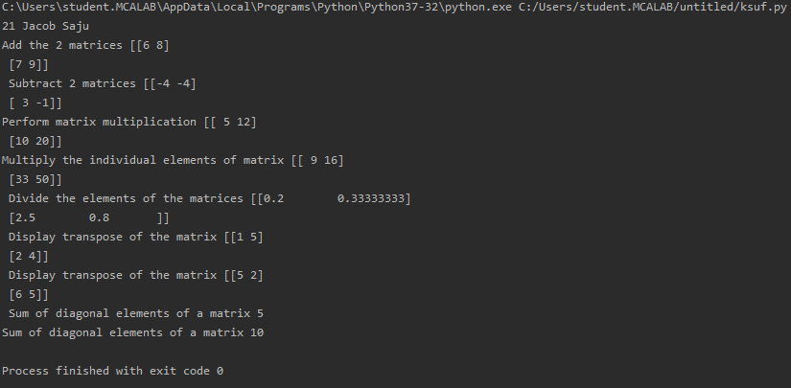

8. Demonstrate the use of insert() function in 1D and 2D array

print("21 Jacob saju")

import numpy as np

arr1=np.array([1,2,3,4,5,6])

print("\narray 1:",arr1)

print("\narray 1 after insertion:",np.insert(arr1,3,9))

arr2=np.array([

[1,2,3],

[6,7,8]

])

print("\narray 2:",arr2)

print("\narray 1 after insertion:\n",np.insert(arr2, 1, np.array((1, 1, 1)), 0))

Output:

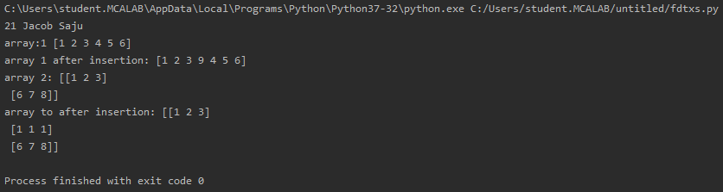

9. Demonstrate the use of diag() function in 1D and 2D array.

print("21 Jacob Saju")

import numpy as np

ar1=np.array([1,2,3])

ar2=np.array([

[2,3,4],

[4,5,6],

[2,1,3]

])

print("diagonal elements of 1st array:",np.diag(ar1))

print("diagonal elements of 2nd array:",np.diag(ar2))

Output:

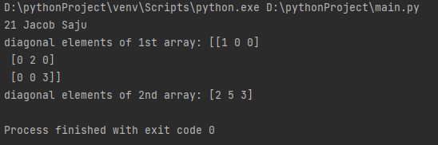

10. Demonstrate the use of append() function in 1D and 2D

array.

print("21 Jacob Saju")

import numpy as np

ar1=np.array([1,2,3])

print("1st array is:",ar1)

print("1d array after append:",np.append(ar1,[4,5,6]))

ar2=np.array([

[5,6,7],

[1,2,7],

[3,4,8]

])

ar3=np.array([

[5,5,7],

[9,2,7],

[3,6,8]

])

print("2nd array:",ar2)

print("2nd array:",ar3)

print("2d array after append:",np.append(ar2,ar3,axis=0))

Output:

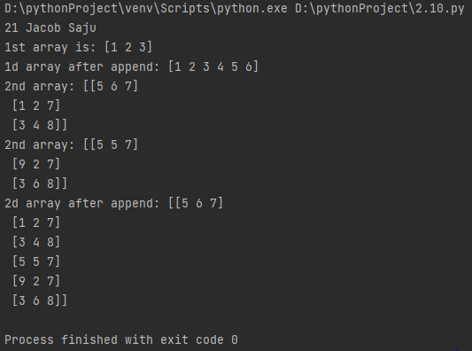

11. Demonstrate the use of sum() function in 1D and 2D array.

print("21 Jacob Saju")

import numpy as np

ar1=np.array([1,2,3])

ar2=np.array([

[5,6,7],

[1,2,7],

])

print("1st array is:",ar1)

print("2nd array:",ar2)

print("sum of 1st array is:",np.sum(ar1))

print("sum of 2nd array is:",np.sum(ar2))

print("sum of column is:",np.sum(ar2,axis=0))

print("row sum is:",np.sum(ar2,axis=1))

Output:

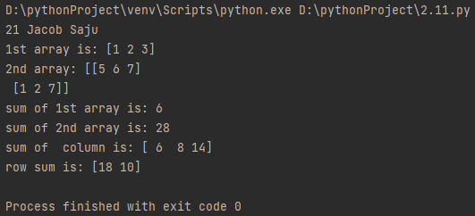

**CYCLE - 2.2**

1. Create a square matrix with random integer values(use randint()) and use

appropriate functions to find:

i) inverse

ii) rank of matrix

iii) Determinant

iv) transform matrix into 1D array

v) eigen values and vectors

print("21 Jacob Saju")

import numpy as np

n=np.random.randint(15,size=(2,2))

print(n)

print("Inverse Of Matrix is:",np.linalg.inv(n))

print("rank of matrix",np.linalg.matrix_rank(n))

print("determinant of matrix",np.linalg.det(n))

d=n.flatten(order='c')

print("One dimensional array is:",d)

u,v=np.linalg.eig(n)

print("eigon value:",u)

print("eigpn vector:",v)

Output:

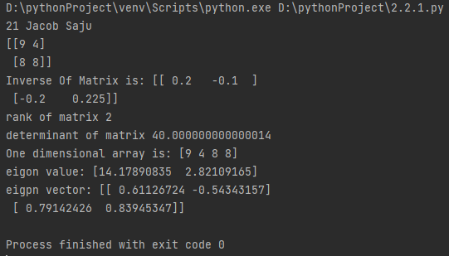

2. Create a matrix X with suitable rows and columns

i) Display the cube of each element of the matrix using different methods

(use multiply(), *, power(),**)

ii) Display identity matrix of the given square matrix.

iii) Display each element of the matrix to different powers.

iv) Create a matrix Y with same dimension as X and perform the operation X 2 +2Y

print("21 Jacob Saju")

import numpy as np

m=np.array([

[2,3],

[4,5]

]

)

print("Matrix is:",m)

print("cube using ,multiply:",np.multiply(m,np.multiply(m,m)))

print("power using multiply:",np.power(m,3))

print("cube using ** :",m**3)

print("cube using *:",m*m*m)

print('identity matrix is:\n',np.identity(2,dtype=int))

print("Display each element of the matrix to different powers.\n",np.power(m,[[1,2],[3,4]]))

n=np.array([[3,7],

[8,9]])

print("m^2+2n\n",(m**2)+(2*n))

Output:

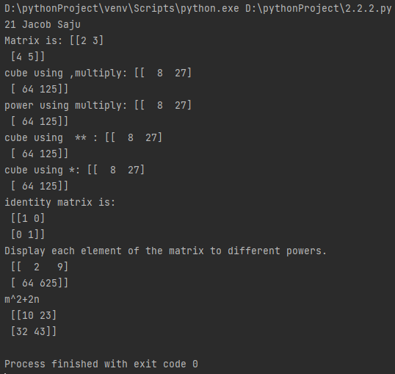

3.Multiply a matrix with a submatrix of another matrix and replace the same in larger

matrix.

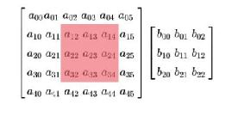

print("21 Jacob saju")

import numpy as np

m1=np.random.randint(0,10,size=(5,6))

m2=np.random.randint(0,10,size=(3,3))

print("Matrix of order 5x6 is:",format(m1))

print("Matrix of order 3x3 is:",format(m2))

m3=m1[1:4,2:5]@m2

m1[1:4,2:5]=m3

print("Matrix after submatrix multiplication:",format(m1))

Output:

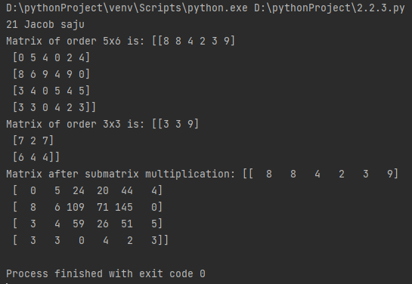

4. Given 3 Matrices A, B and C. Write a program to perform matrix multiplication of

the 3 matrices.

print("21 Jacob Saju")

import numpy as np

m1=np.random.randint(0,10,size=(2,2))

m2=np.random.randint(0,10,size=(2,3))

m3=np.random.randint(0,10,size=(3,3))

print("first ,matrix is:",format(m1))

print("second matrix is:",format(m2))

print("third matrix is:",format(m3))

m4=np.matmul(np.matmul(m1,m2),m3)

print("After Multiplication:",m4)

Output:

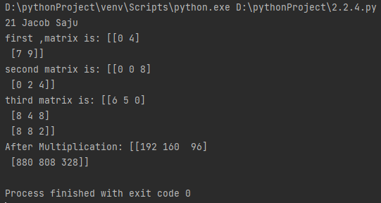

5. Write a program to check whether given matrix is symmetric or Skew Symmetric.

print("21 Jacob Saju")

import numpy as np

#m1=np.random.randint(0,10,size=(3,3))

m1=np.matrix([

[1,2,3],

[2,-5,7],

[3,5,7]

])

print("Matrix is:",format(m1))

m2=m1.transpose()

if m1.all() == m2.all():

print("Matrix is symmetric")

else:

print("Matrix is not symmetric")

if np.allclose(-m1,m2)==True:

print("Matrix is skew symmetric")

else:

print("Matrix is not skew symmetric")

Output:

6. Write a program to find out the value of X using solve(), given A and b as below.

Solving systems of equations with numpy

One of the more common problems in linear algebra is solving a matrix-vector equation.

Here is an example. We seek the vector x that solves the equation

A X = b

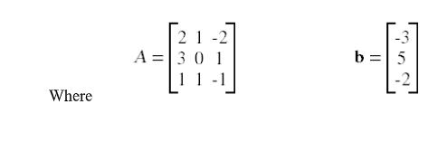

And X=A -1 b.

Numpy provides a function called solve for solving such equations.

print("21 jacob saju")

import numpy as np

m1=np.array([

[2,1,3],

[4,5,6],

[7,5,1]

])

m2=np.array([2,3,4])

x = np.linalg.solve(m1,m2)

print(" X=",x)

print(np.allclose(np.dot(m1, x), m2))

Output:

**Lab Cycle 3**

1. Sarah bought a new car in 2001 for $24,000. The dollar value of her car changed each year as shown in

the table below.

Value of Sarah&#39;s Car

Year Value

2001 $24,000

2002 $22,500

2003 $19,700

2004 $17,500

2005 $14,500

2006 $10,000

2007 $ 5,800

Represent the following information using a line graph with following style properties

X- axis - Year

Y –axis - Car Value

title –Value Depreciation (left Aligned)

Line Style dashdot and Line-color should be red

point using * symbol with green color and size 20

**print('21 Jacob Saju')**

**import matplotlib.pyplot as plt**

**import numpy as np**

**xpoints = np.array([2001,2002,2003,2004,2005,2006,2007])**

**ypoints = np.array([24000,22500,19700,17500,14500,10000,5800])**

**plt.plot(xpoints,ypoints,linestyle = 'dashdot', color ='red', marker='*',ms=20, mfc='green')**

**plt.title(label= "value Depreciation",loc='left')**

**plt.xlabel("year")**

**plt.ylabel("car value")**

**plt.show()**

Output

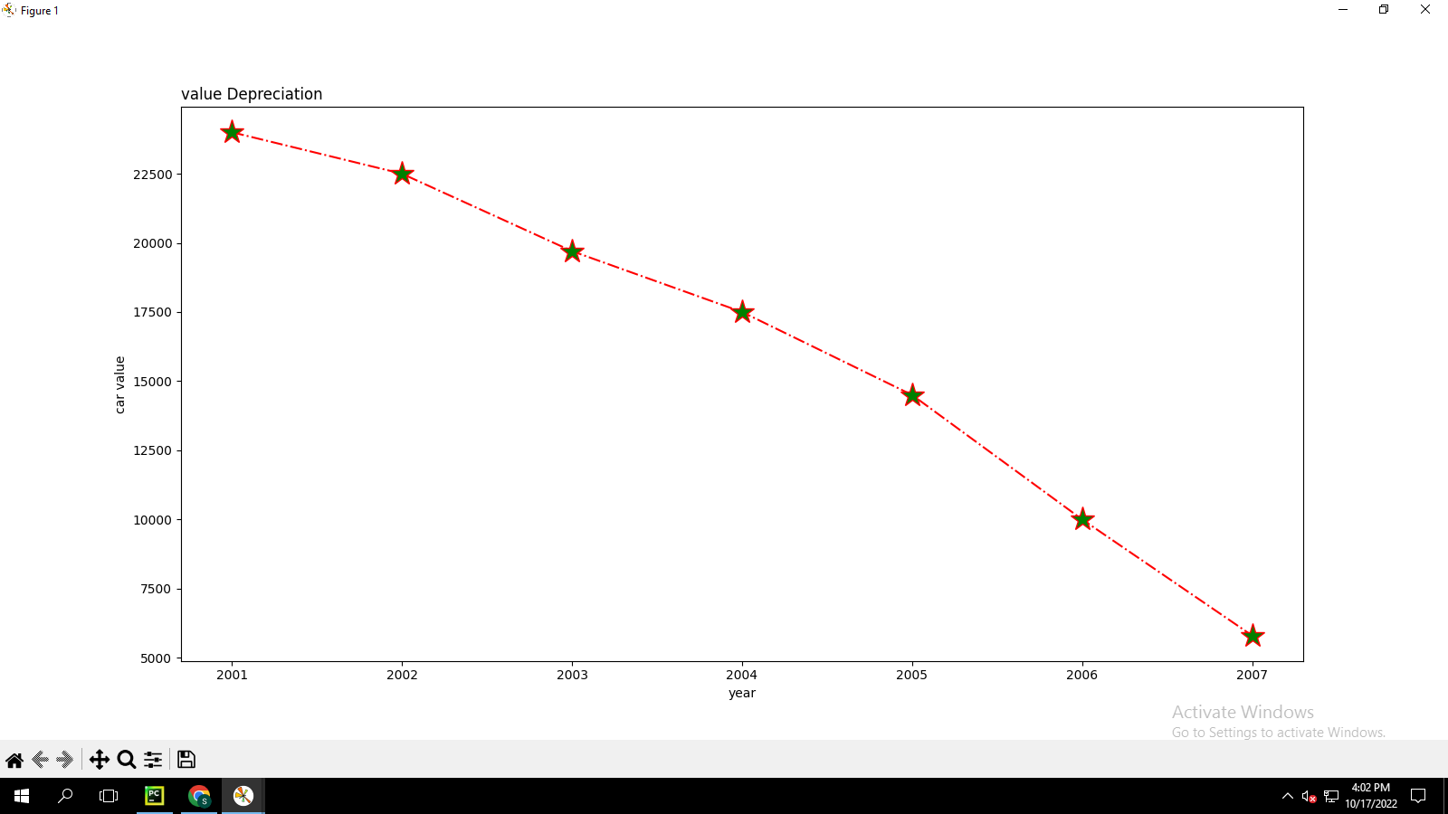

2. Following table gives the daily sales of the following items in a shop

Day Mon Tues Wed Thurs Fri

Drinks 300 450 150 400 650

Food 400 500 350 300 500

Use subplot function to draw the line graphs with grids(color as blue and line style dotted) for the

above information as 2 separate graphs in two rows

a) Properties for the Graph 1:

X label- Days of week

Y label-Sale of Drinks

Title-Sales Data1 (right aligned)

Line –dotted with cyan color

Points- hexagon shape with color magenta and outline black

b) Properties for the Graph 2:

X label- Days of Week

Y label-Sale of Food

Title-Sales Data2 ( center aligned)

Line –dashed with yellow color

Points- diamond shape with color green and outline red

print('21 Jacob Saju')

import matplotlib.pyplot as plt

import numpy as np

#plot 1:

x = np.array(['Mon','tues','wed','thurs','fri'])

y = np.array([300,450,150,400,650])

plt.subplot(1,2,1)

plt.plot(x,y)

plt.xlabel('Days of Week')

plt.ylabel('Sales of drinks')

plt.title(label= "Sales data 1",loc='right')

plt.plot(x,y,linestyle = 'dotted',color='cyan',marker= 'H',mfc='magenta',mec='black')

plt.grid(color = 'blue', linestyle = 'dotted')

#plot 2

x = np.array(['Mon','tues','wed','thurs','fri'])

y = np.array([400,500,350,300,500])

plt.subplot(1,2,2)

plt.plot(x,y)

plt.xlabel('Days of Week')

plt.ylabel('Sales of food')

plt.title(label= "Sales data 2",loc='center')

plt.grid(color = 'blue', linestyle = 'dotted')

plt.plot(x,y,linestyle = 'dashed',color='yellow',marker= 'D',mfc='green',mec='red')

plt.show()

Output

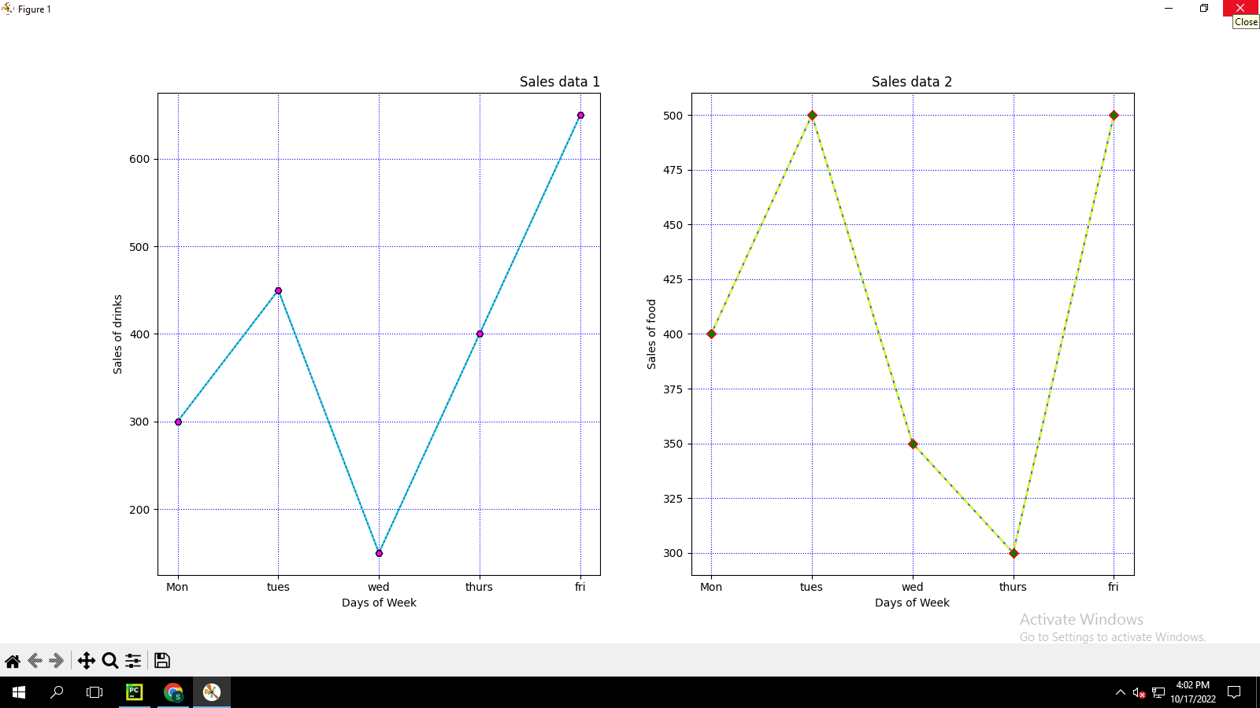

3. Create scatter plot for the below data:(use Scatter function)

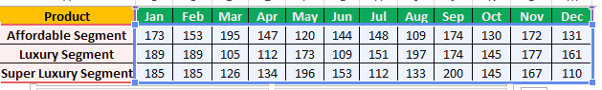

Create scatter plot for each Segment with following properties within one graph

X Label- Months of Year with font size 18

Y-Label- Sales of Segments

Title –Sales Data

Color for Affordable segment- pink

Color for Luxury Segment- Yellow

Color for Super luxury segment-blue

**Cycle-4**

1.DATA HANDLING USING ‘Pandas’ and DATA VISUALIZATION USING ‘Seaborn’

Using the pandas function read_csv(), read the given ‘iris’ data set.

1. Use appropriate functions in pandas to display

(i) Shape of the data set

(ii) First 5 and last five rows of data set(head and tail)

(iii) Size of dataset

(iv) No:of samples available for each variety

(v) Description of the data set( use describe.

print('21 Jacob Saju ')

import pandas as pd

df = pd.read_csv('iris.csv')

print(df.to_string())

shape=df.shape

#q1

print("Shape of the data set",shape)

print("\n")

print("First 5 and last five rows of data set(head)",df.head())

print("\n")

print("First 5 and last five rows of data set(tail)",df.tail())

print("\n")

print("Size of dataset",df.size)

print("\n")

print("No:of samples available for each variety",df["variety"].value_counts())

print("\n")

print("Description of the data set( use describe)",df.describe())

Output

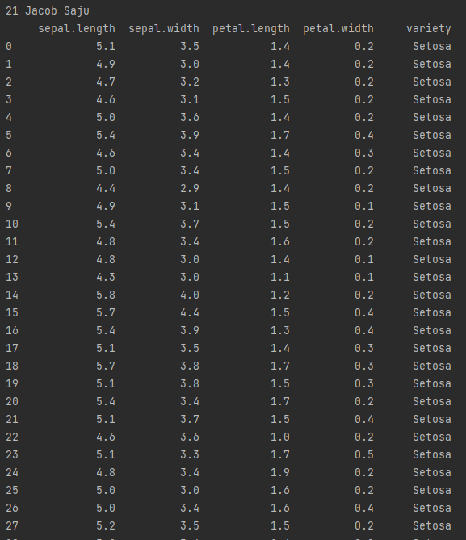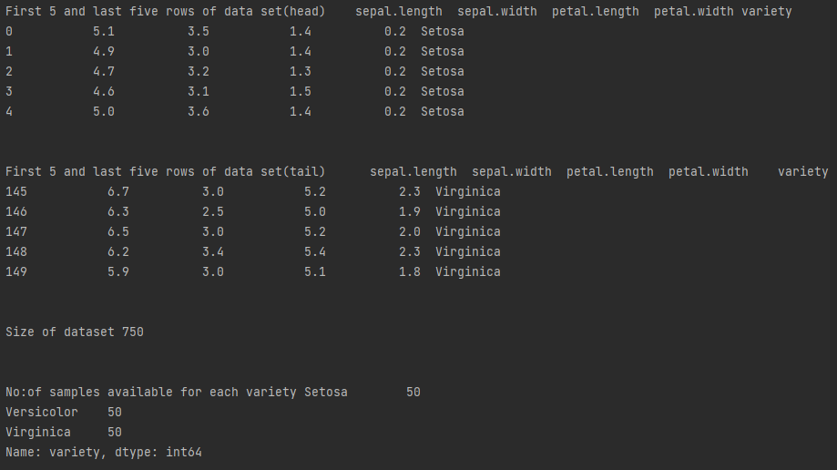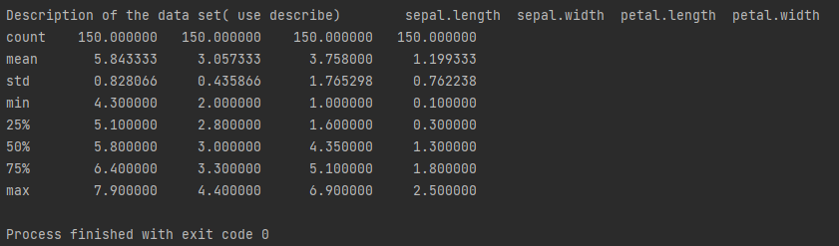

2. Use pairplot() function to display pairwise relationships between attributes. Try

different kind of plots {‘scatter’, ‘kde’, ‘hist’, ‘reg’} and different kind of markers.

print("21 Jacob Saju")

import pandas as pd

import seaborn as sns

import matplotlib .pyplot as plt

data=pd.read_csv("iris.csv")

iris = sns.load_dataset("iris")

plot=sns.pairplot(iris)

sns.pairplot(iris, hue="species", kind="hist")

plt.show()

sns.pairplot(iris, kind="kde")

plt.show()

sns.pairplot(iris, kind="reg", hue="species")

plt.show()

sns.pairplot(iris,kind="scatter")

plt.show()

Output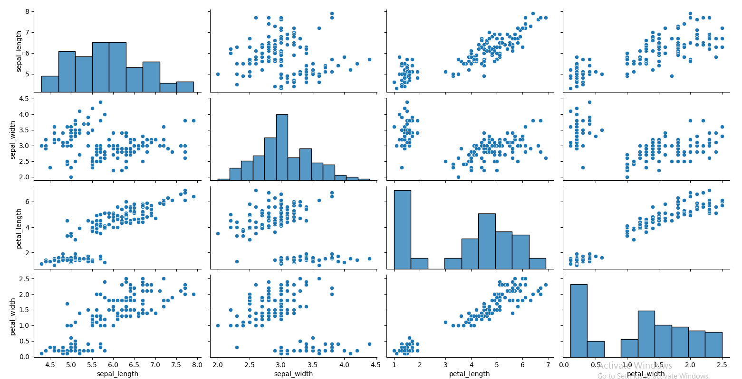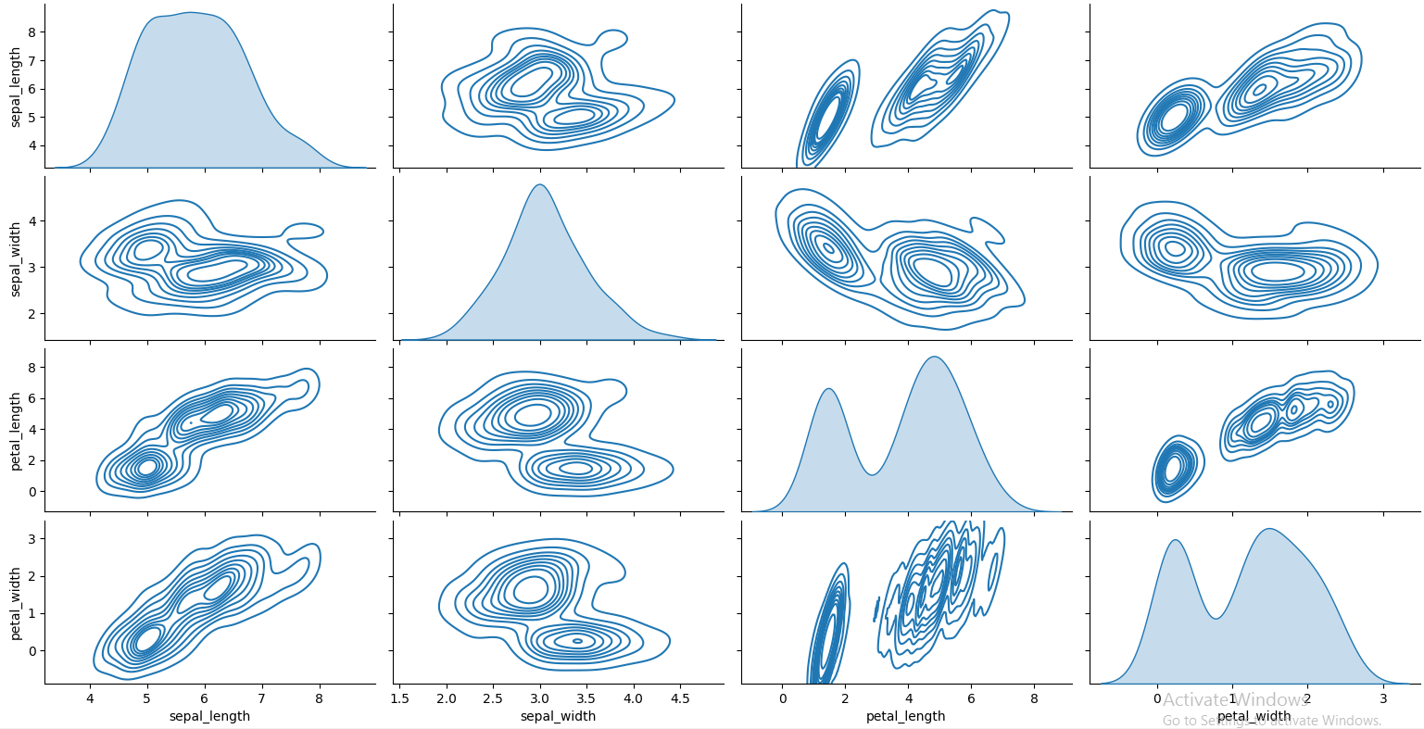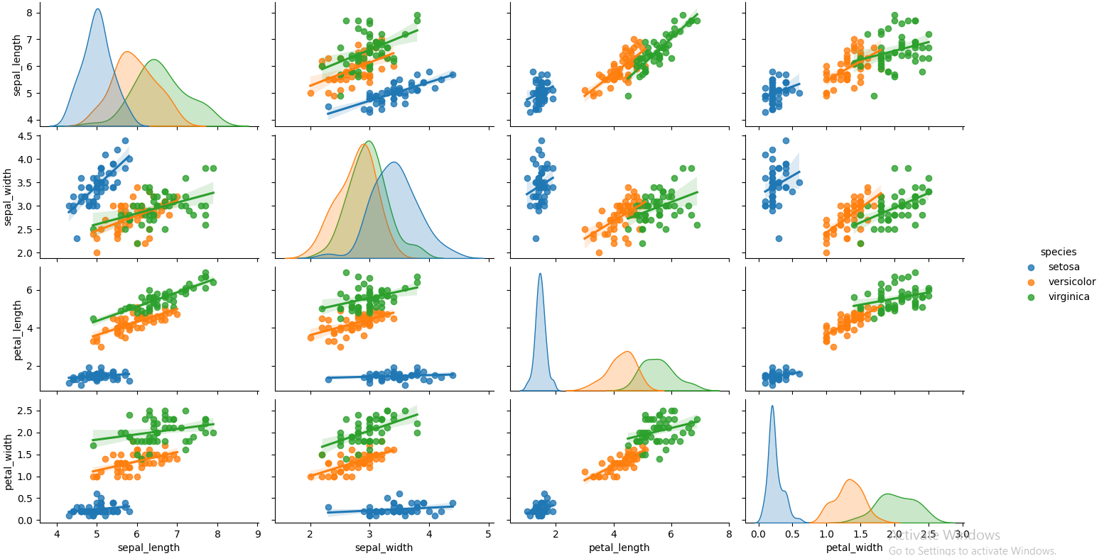

**Cycle-4.2**

1. Using the iris data set implement the KNN algorithm. Take different values for Test and training

data set .Also use different values for k. Also find the accuracy level.

**print("21 Jacob Saju")**

**import numpy as np**

**import pandas as pd**

**import matplotlib.pyplot as plt**

**from sklearn.neighbors import KNeighborsClassifier**

**from sklearn.model_selection import train_test_split**

**iris=pd.read_csv("iris.csv")**

**X = iris.iloc[:,:-1].values**

**y = iris.iloc[:,4].values**

**X_train, X_test, y_train, y_test = train_test_split( X, y, test_size=0.20)**

**knn = KNeighborsClassifier(n_neighbors=5)**

**knn.fit(X_train, y_train)**

**y_pred=knn.predict(X_test)**

**from sklearn.metrics import classification_report,confusion_matrix**

**print(classification_report(y_test,y_pred))**

3. Using iris data set, implement naive bayes classification for different naive Bayes classification

algorithms.( (i) gaussian (ii) bernoulli etc)

Find out the accuracy level w.r.t to each algorithm

Display the no:of mislabeled classification from test data set

List out the class labels of the mismatching records